 RETAIL MANAGEMENT APPLICATIONS USING

SALESFORCE

1. **INTRODUCTION** 
   1. Overview :

WHAT IS RETAIL?

Retailing includes all activities involved in selling goods or services to the final consumers for personal, non-business use.Any organization that sells the products for consumption to the customers for their personal, family, or household use is in the occupation of retailing.Retailor provides the goods that customer needs, in a desired form, at a required time and place.A retailor does not sell raw material. He sells finished goods or services in the form that customer wants.A retailer buys a wide range of products from different wholesalers and offers the best products under one roof. Thus, the retailor performs the function of both buying and selling.

* 1. Purpose :Effective Management controls shopliftings to a large extent.The retailer must keep a record of all the products coming into the store.The products must be well arranged on the assigned shelves according to size, colour, gender, patterns etc.Plan the store layout well.The range of products available at the store must be divided into small groups comprising of similar products. Such groups are called categories. A customer can simply walk up to a particular category and look for products without much assistance.A unique SKU code must be assigned to each and every product for easy tracking.necessary labels must be put on the shelves for the customers to locate the merchandise on their own. Don’t keep the customers waiting.Make sure the sales representatives attend the customers well. Assist them in their shopping. Greet them with a smile. The retailer must ensure enough stock is available at the store.Make sure the store is kept clean. Don’t stock unnecessary furniture as it gives a cluttered look to the store. The customers must be able to move freely.The store manager, department managers, cashier and all other employees should be trained from time to time to extract the best out of them. They should be well aware of their roles and responsibilities and customer oriented. They should be experts in their respective areas.The store manager must make daily sales reports to keep a track of the cash flow. Use softwares or maintain registers for the same.Remove the unsold merchandise from the shelves. Keep them somewhere else.Create an attractive display.Plan things well in advance to avoid confusions later on.Ask the customers to produce bills in case of exchange. Assign fixed timings for the same.

**2.Problem Definition & Design Thinking**

2.1 Empathy Map

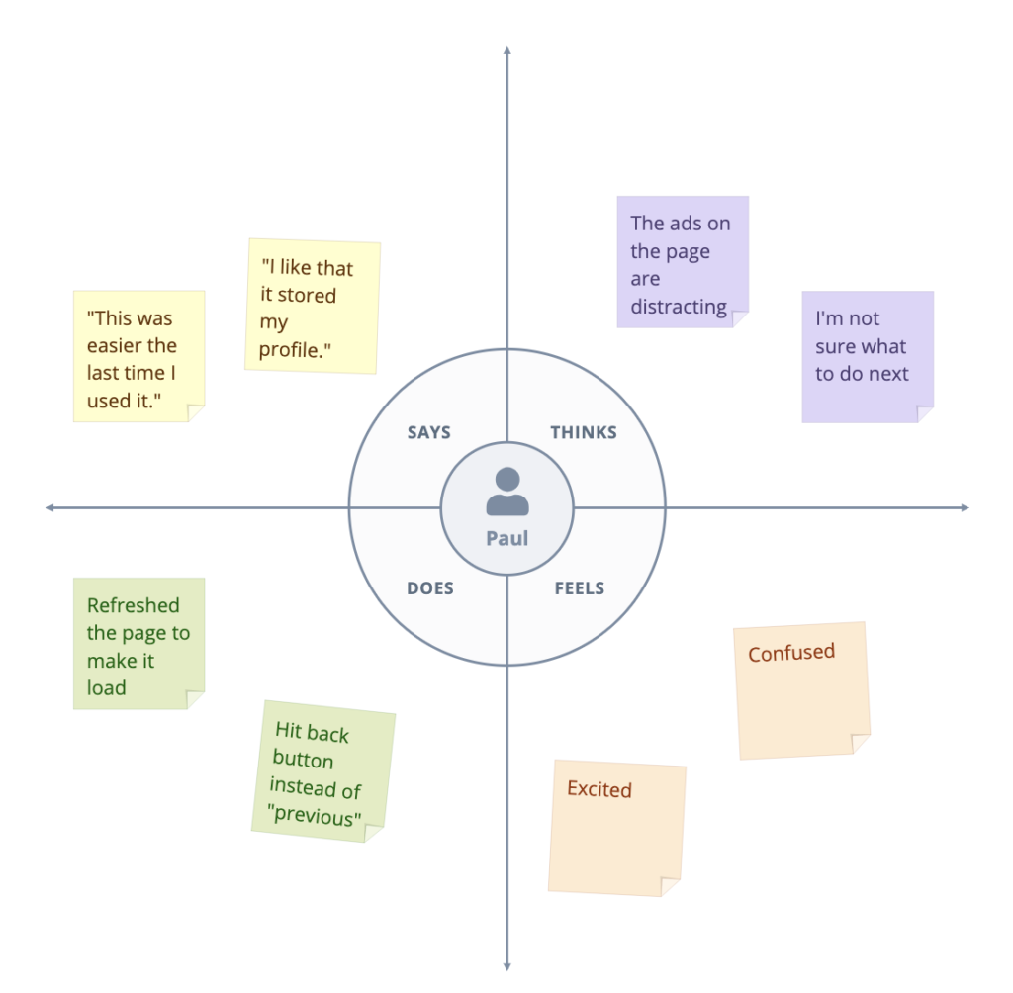

2.2 Ideation & Brainstorming Map 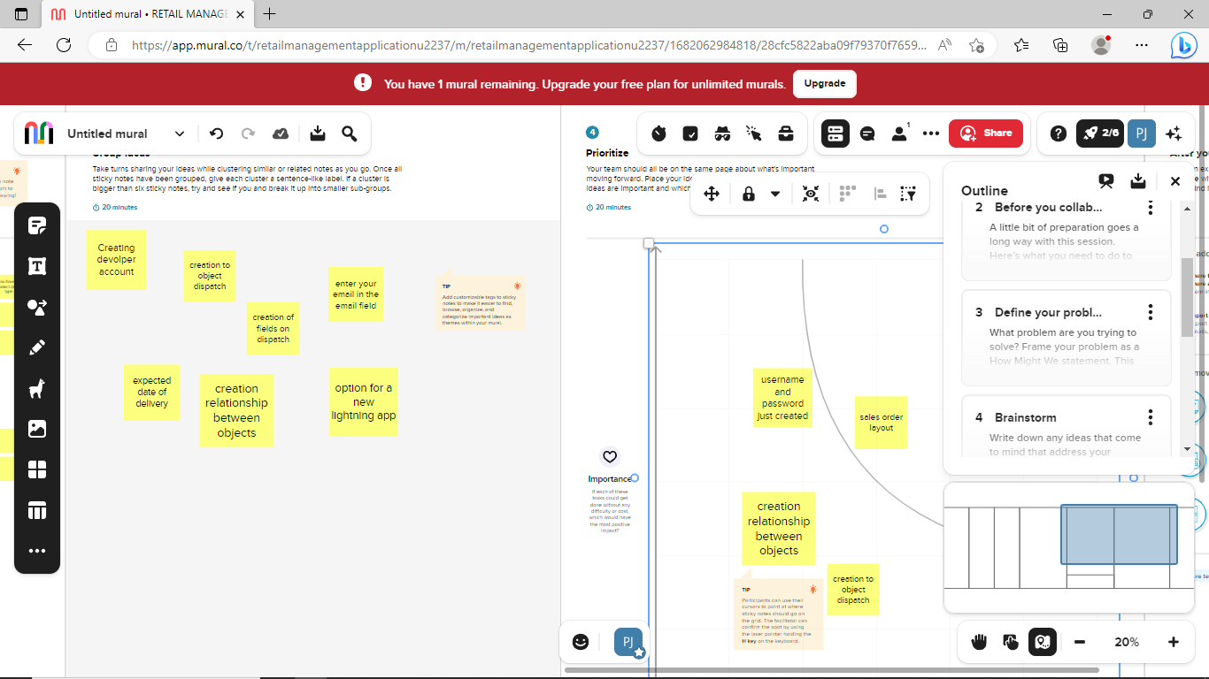

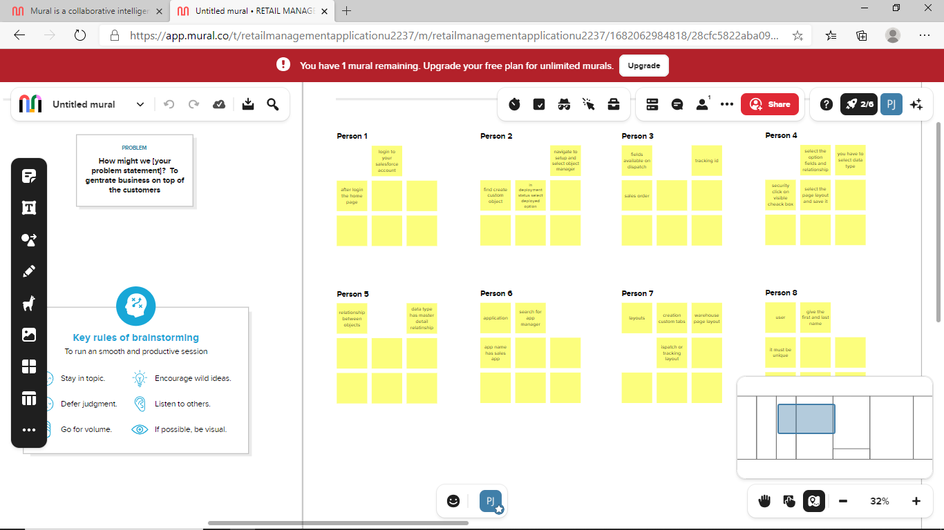

1. **RESULT**

* 1. Data Model:

| student | Field label Data type  students text |  |  |  |
| --- | --- | --- | --- | --- |
| Sales order | Field label Data type  Salea orders master detail |  |  |  |
| **Object name** | **Fields in the Object** |  |  |  |
| Parents | | Field label | Data type | | --- | --- | | parents | text | |  |  | |  |  |  |
| Dispatch | | Field label | Data type | | --- | --- | | expected data of delivery | cellphone | |  |  | |  |  |  |

* 1. **Activity & Screenshot**

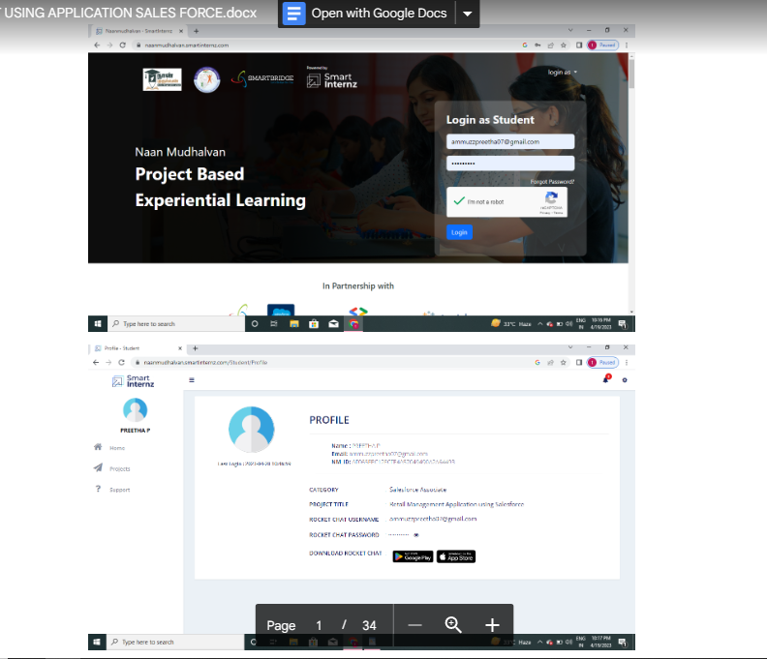

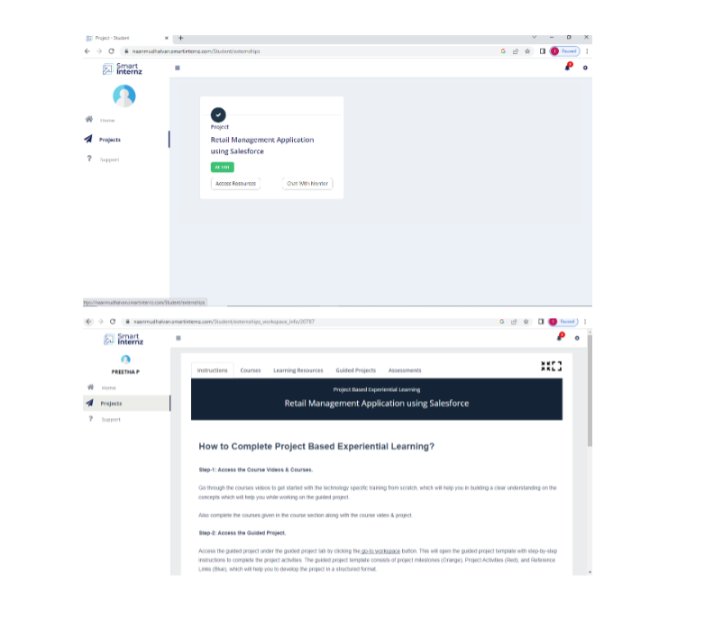

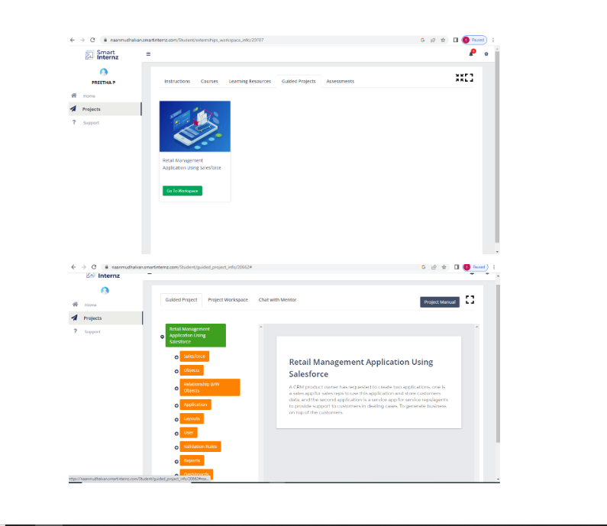

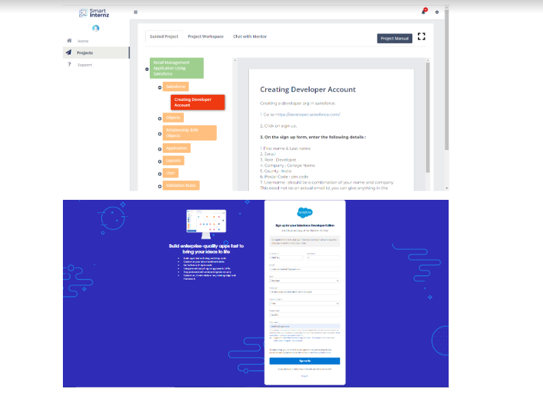

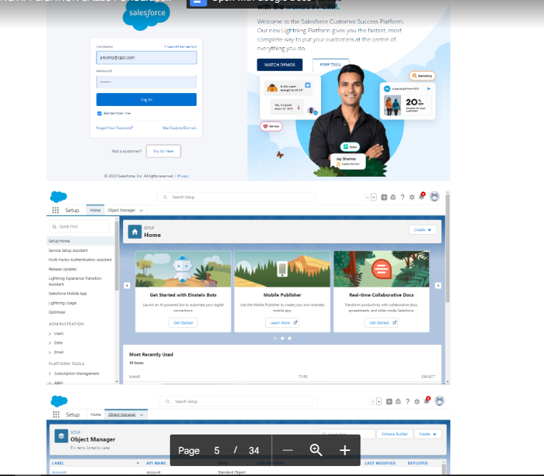

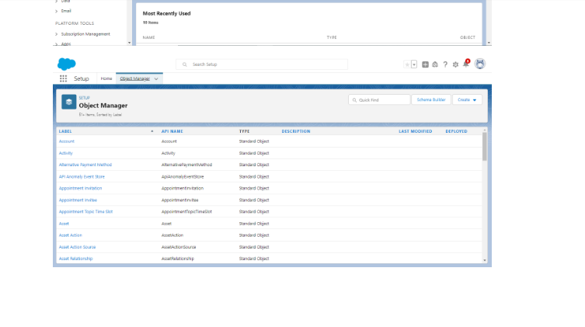

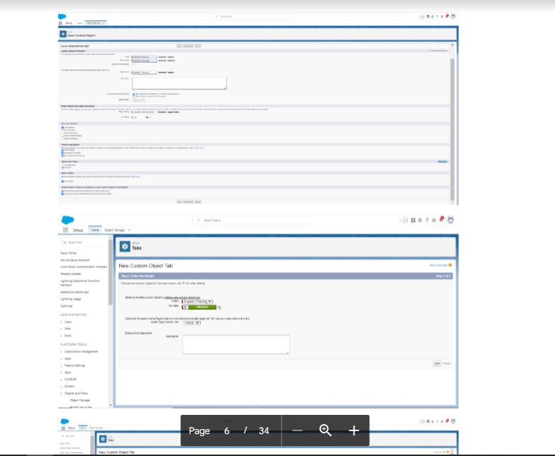

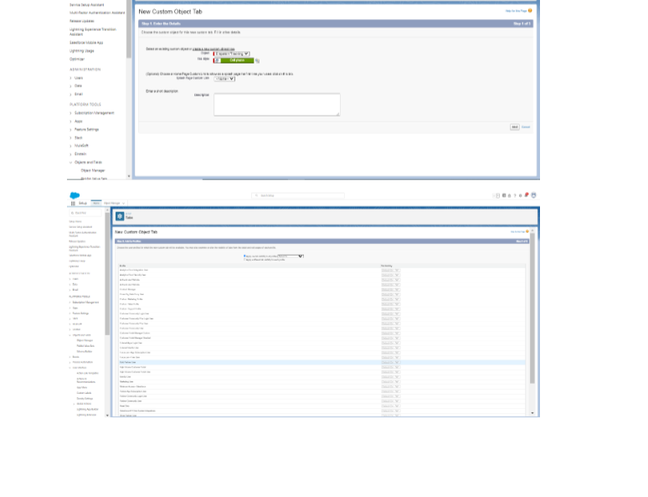

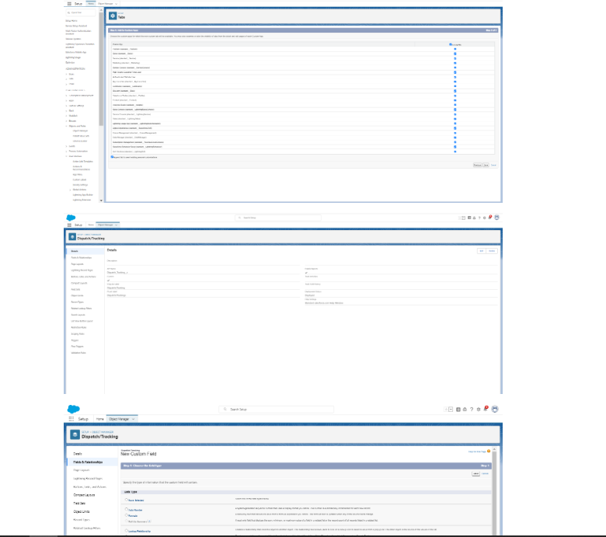

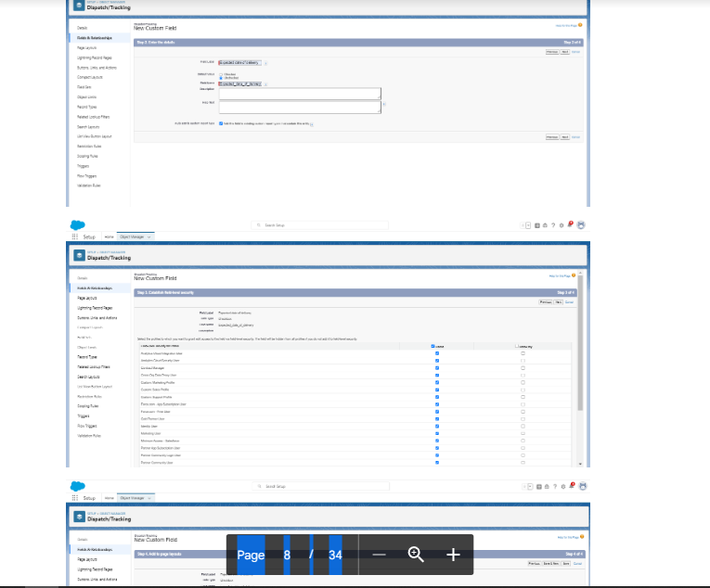

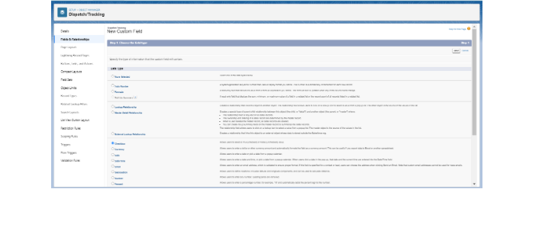

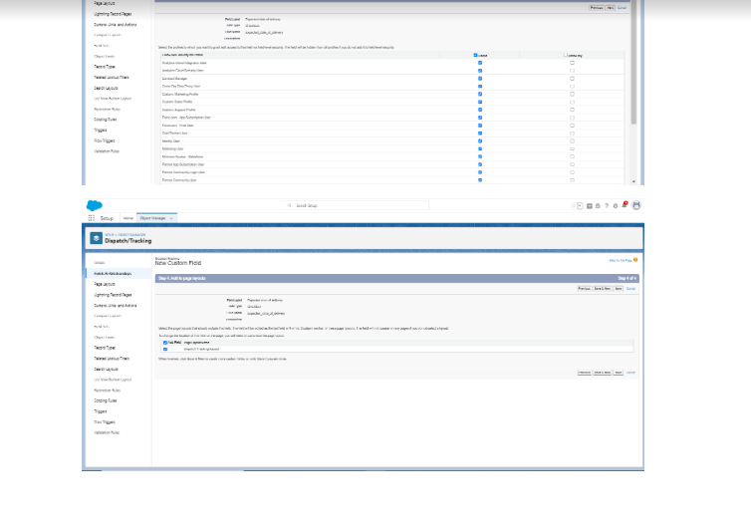

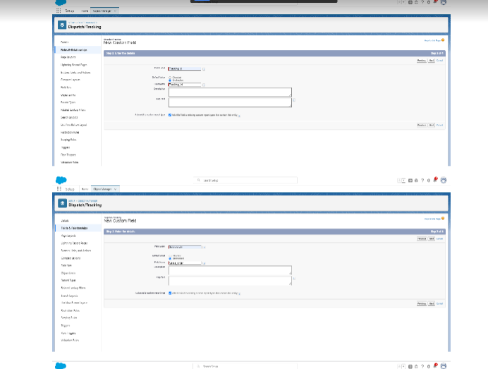

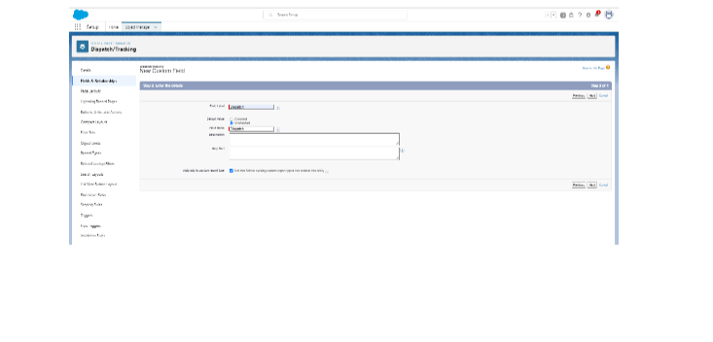

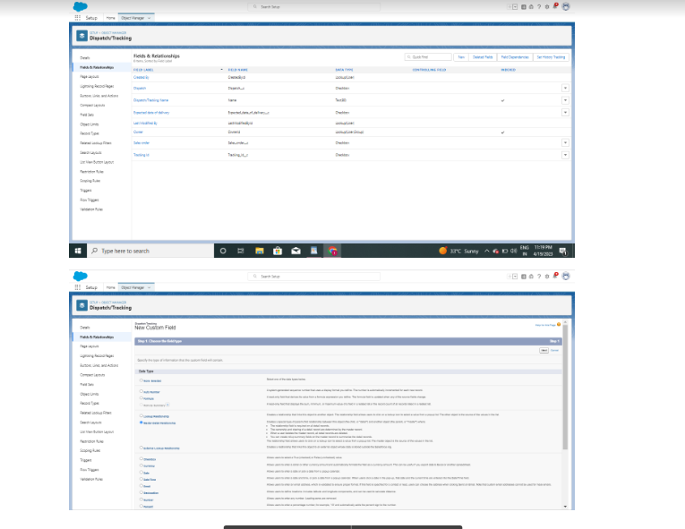

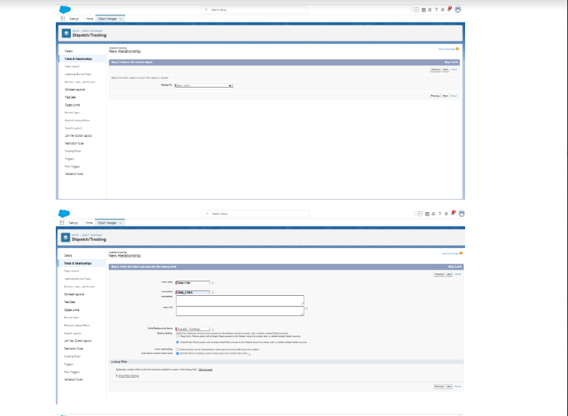

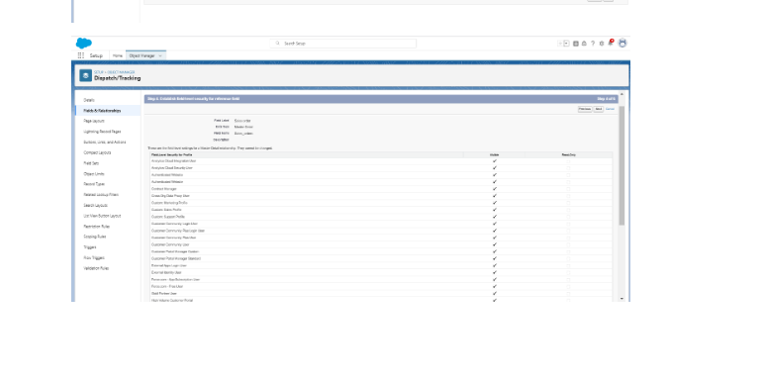

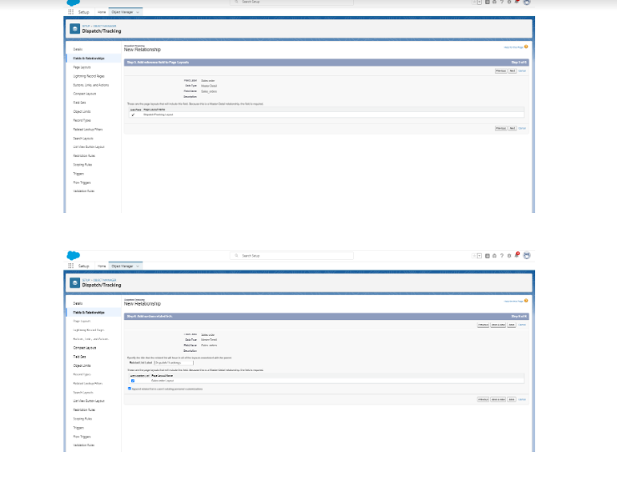

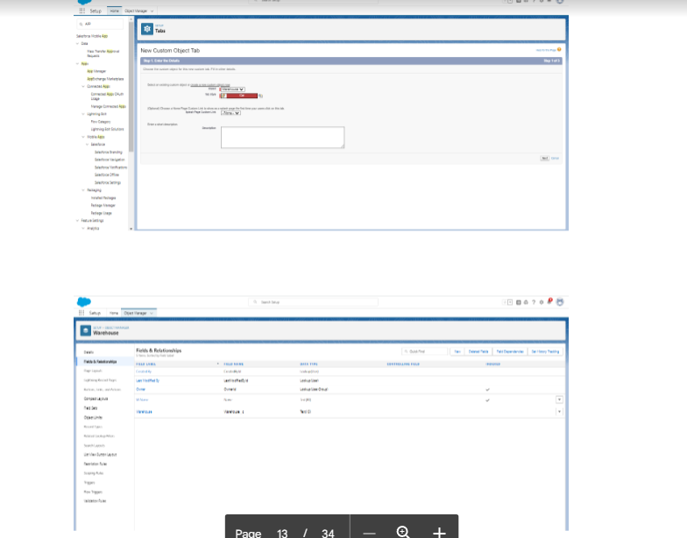

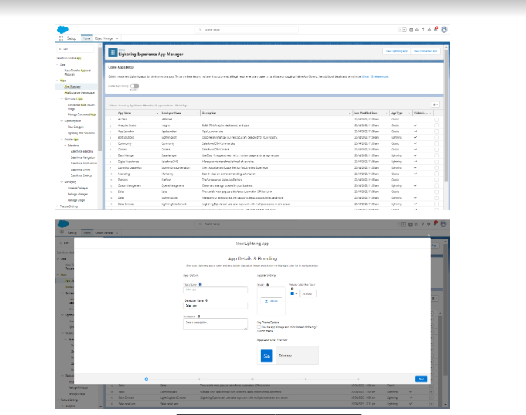

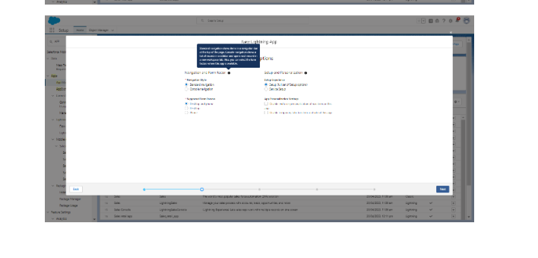

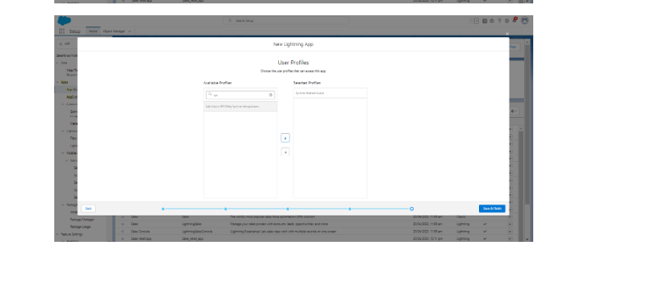

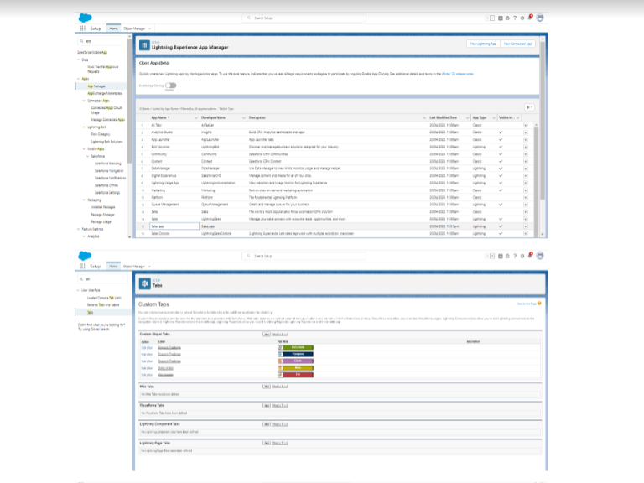

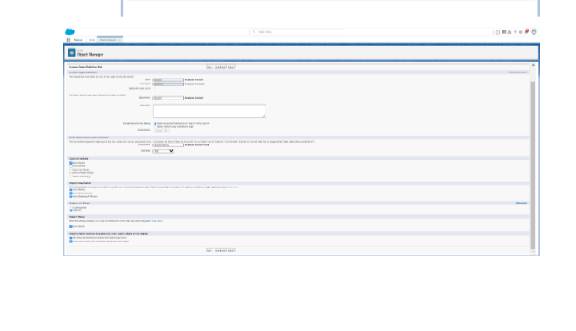

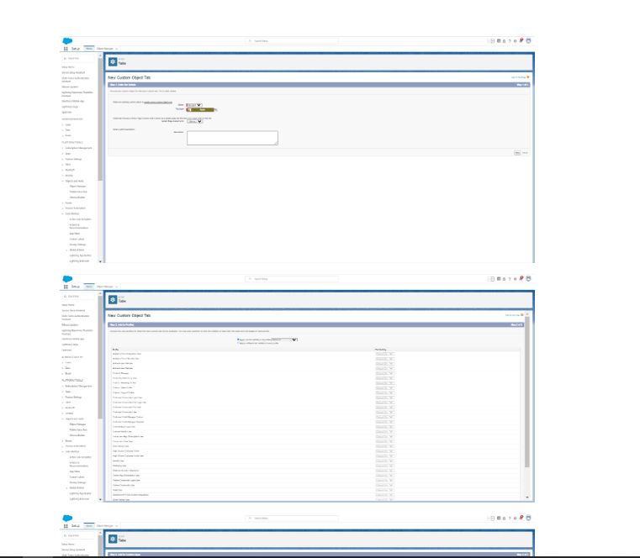

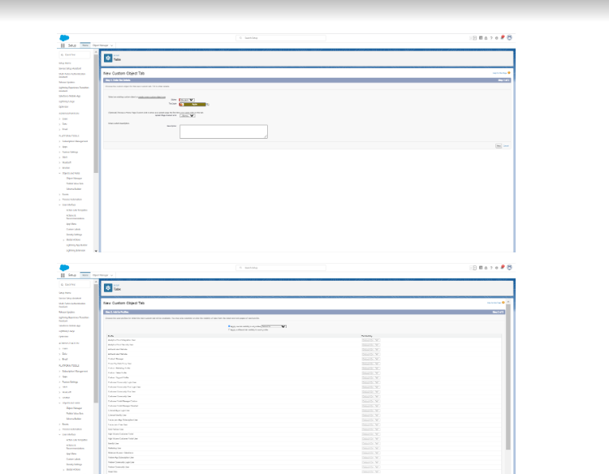

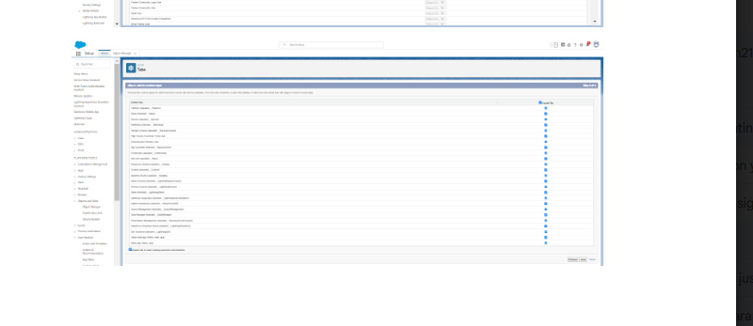

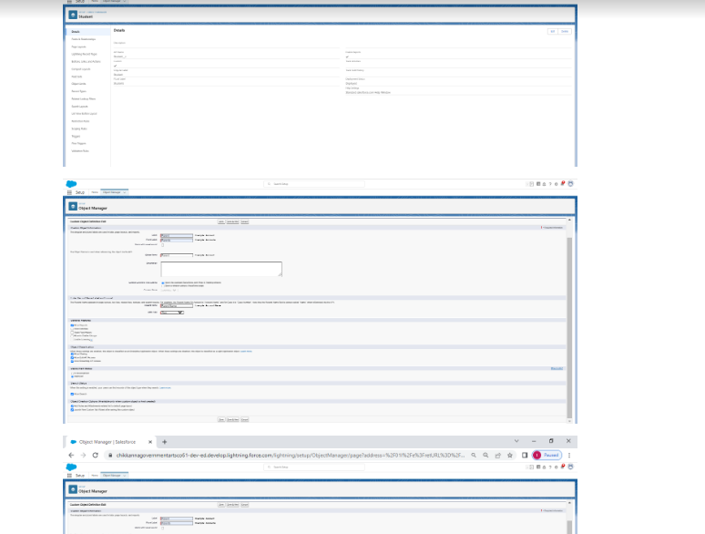

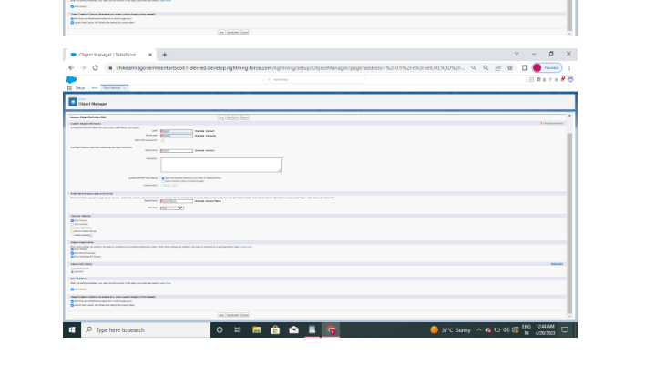

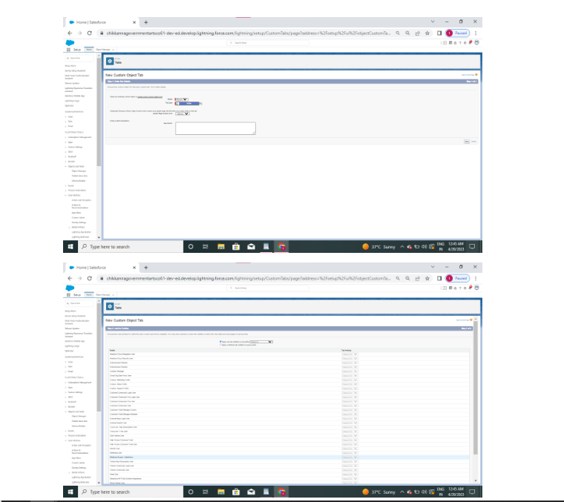

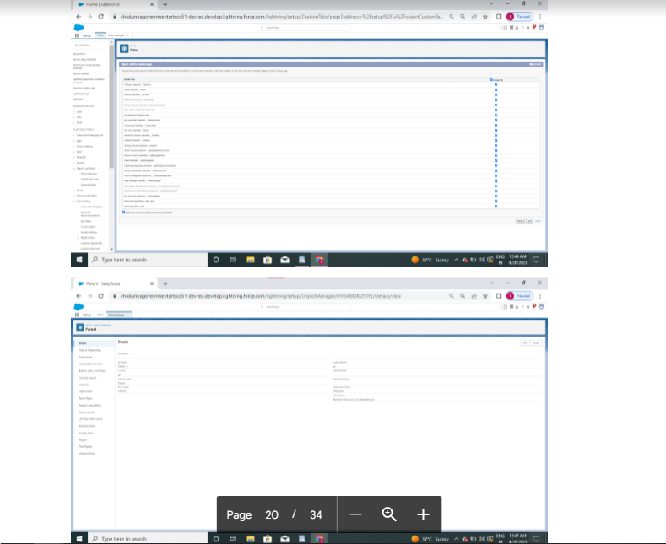

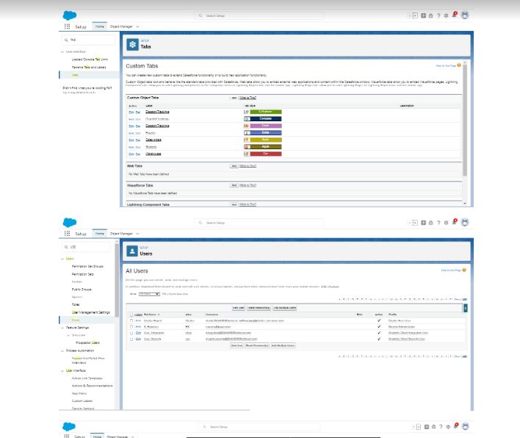

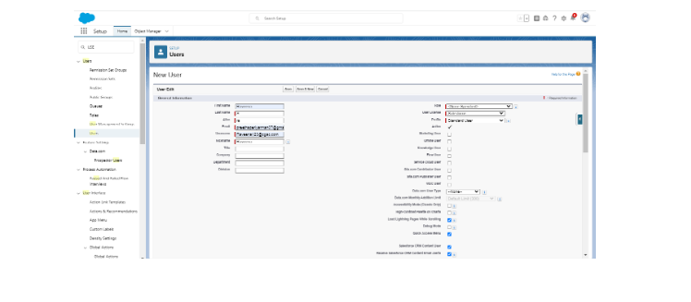

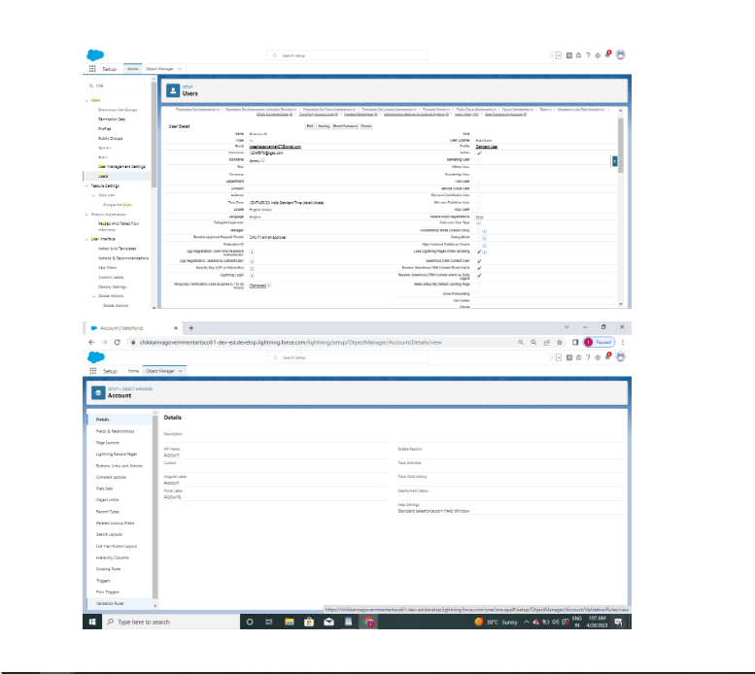

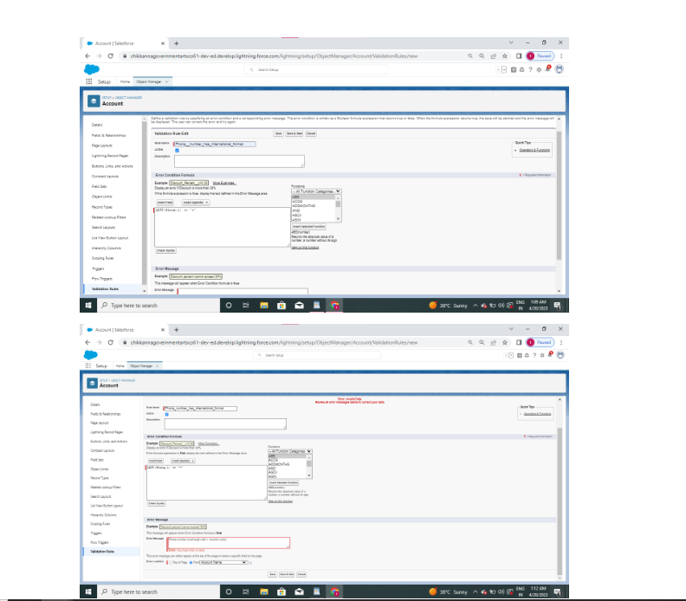

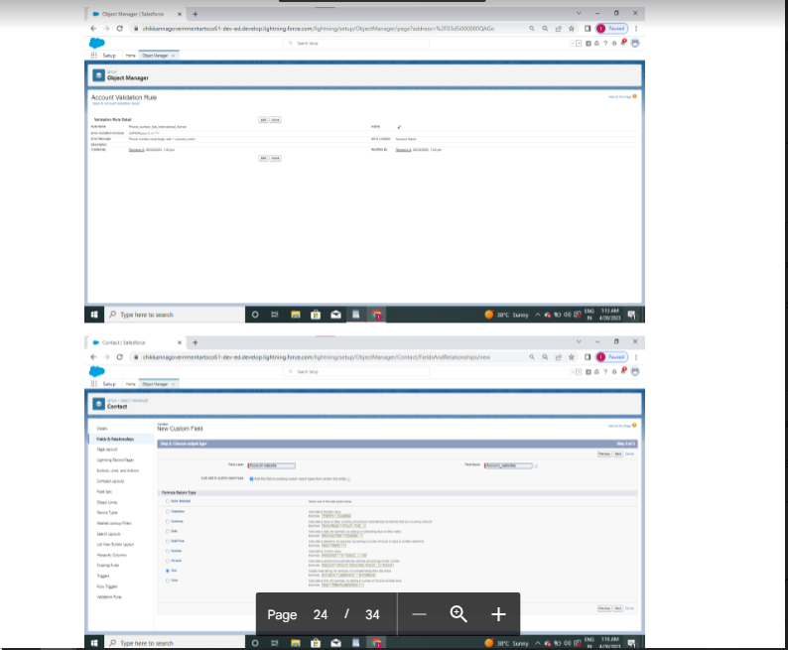

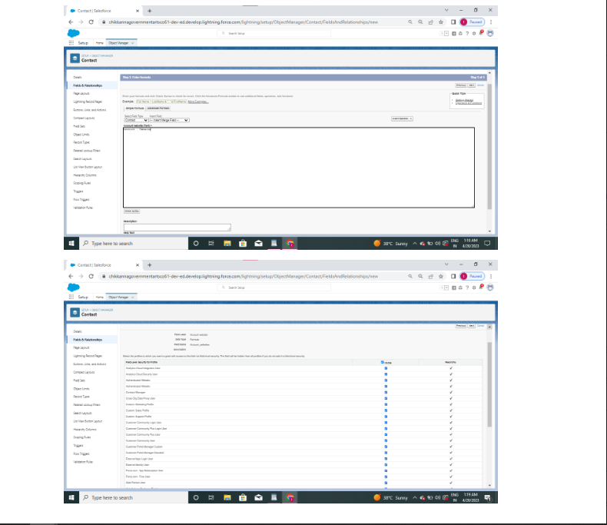

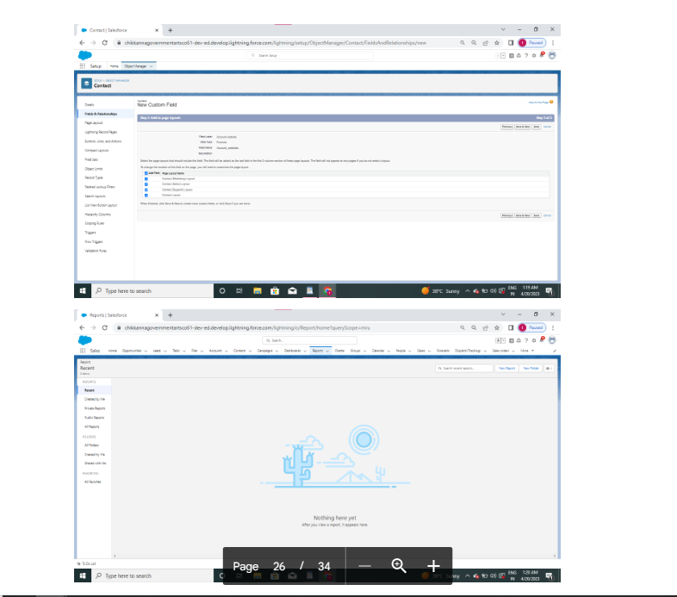

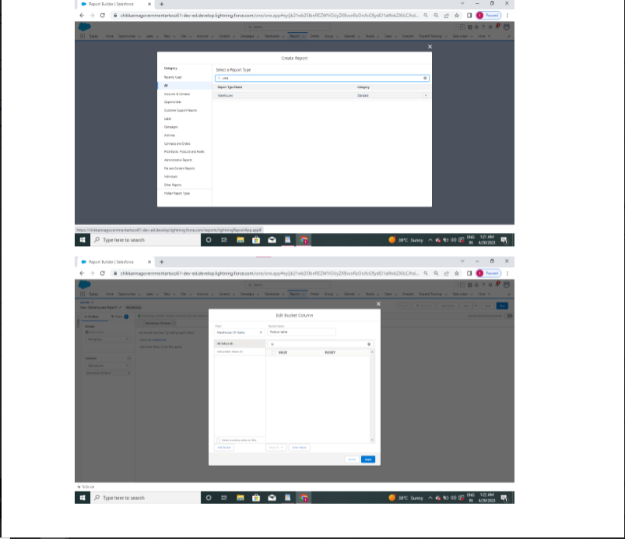

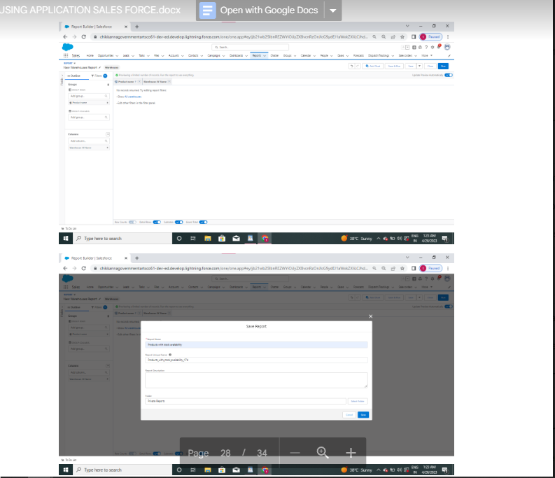

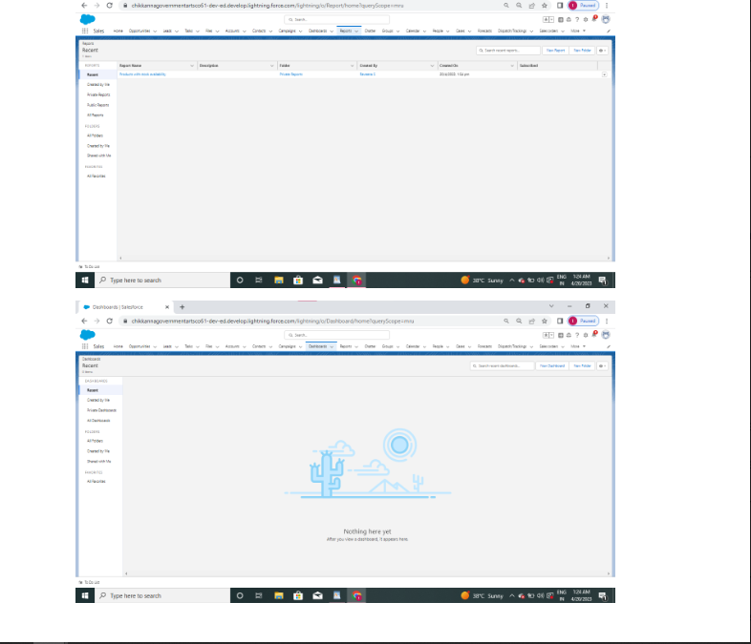

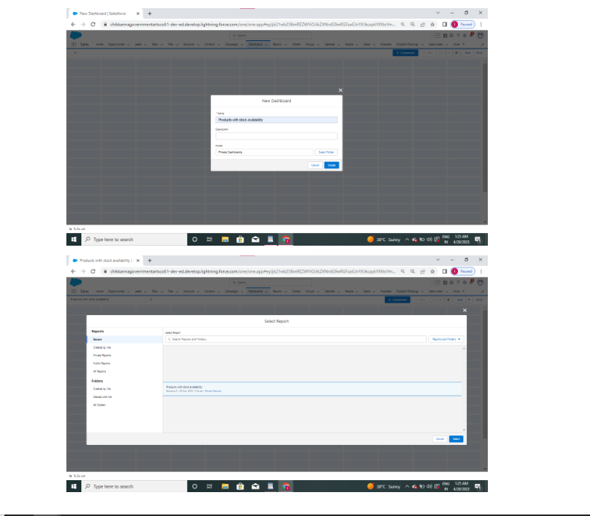

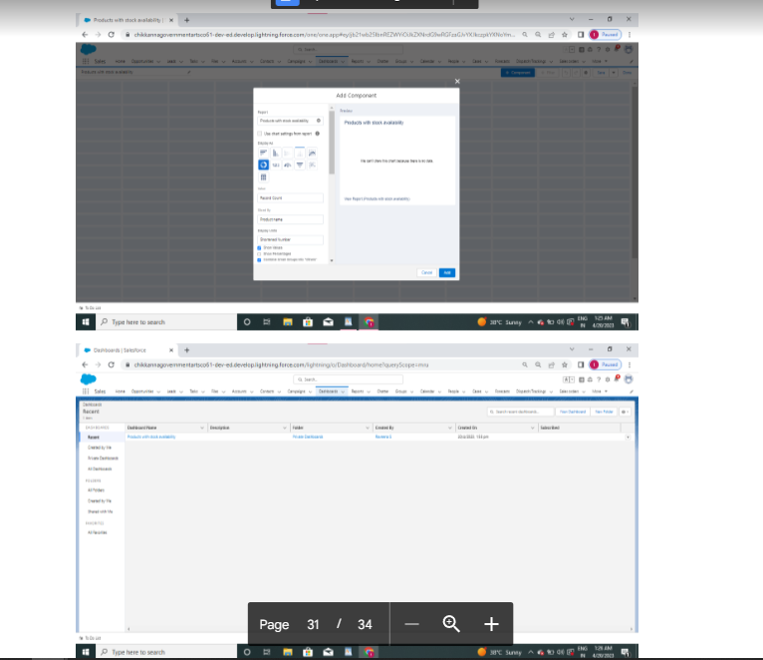

1. **Trailhead Profile Public URL**

**Team Lead(S.DHARANI) -** <https://trailblazer.me/id/dhars233>

**Team Member 1 (J.PAVITHRA)-** [**https://trailblazer.me/id/spavi42**](https://trailblazer.me/id/spavi42)

**Team Member 2 (P.PREETHA) -** [**https://trailblazer.me/id/preep7**](https://trailblazer.me/id/preep7)

**Team Member 3 (S.SWETHA) –** [**https://trailblazer.me/id/swets49**](https://trailblazer.me/id/swets49)

1. **ADVANTAGES & DISADVANTAGE**

**ADVANTAGES:**

**The biggest advantage of retailing is that it is a cash business implying that a retailer will always sell goods on cash to its customers and since wholesaler gives goods to retailers on credit of 30 to 60 days it is the retailer who enjoys liquidity as he or she is selling goods in cash and getting credit from wholesalers.Another benefit of the retailer is that he or she has no liability towards the customer because if the product is defective then it is the producer who will bear the loss of replacing the product. In simple words, retailer is immune as far as a liability from a customer point of view is concerned as he or she is the mediator between the producer and the consumer.**

### DISADVANTAGES:

**The biggest problem with retail business is that profit margins of this business is fixed which ranges from 5 to 20 percent depending upon the brand of the product which retailer is selling and also unlike wholesaler who can expand business in order to achieve economies of scale in case of retailing such thing is not possible.Another problem of retail shops is that good location is one of the factors in order to be successful in retail business and if you are the owner of building than it is not much of a problem but if you take shop on rent than you have to pay high rent in order to take shop on rent at good location. Hence one needs to keep location factor in mind before deciding to be a retailer.**

1. **APPLICATIONS:**

**Easily navigate and visualize all key agency, advertiser, and brand relationships. Get unified visibility into all advertising inventory across all channels in a singular view. computer the picture with holistic and reconciled, omni-channel analytics in one platformIncrease revenues through intelligent recommendations to monetize underutilized cross-channel ad inventory. Ensure pricing consistency with a centralized, flexible product catalog and rate card. Optimize revenue with a media planner built on a configure, price, quote (CPQ) engine that supports attribute-based pricing and highly complex issues**

1. **CONCLUSION :Whether you have a small shop or a mega store, if you own a retail business, then retail management is a must to run it effectively and efficiently.From the above discussion, we can realize the importance of retail management. It helps retailers save time and gain customer satisfaction. The customers become evangelists and wish to visit the store again and again.Hence, the whole concept of retail management helps the retailer to get rid of the chaos and run his business successfully.If you are a brand looking for retail expansion and strengthening your offline retail footprints.**
2. **FUTURE SCOPE :**

**The retail sector in the country is currently booming, providing plenty of career prospects for people with a passion for sales marketplaces, business diversification, campaigning, advertising, market research, and segmentation. With the continuous expansion of the retail industry, there is a growing demand for retail courses that will prepare students to cope with the tactics, procedures, and methods that will help them generate more sales and customer satisfaction.Retail management has become one of the fastest-growing occupations in the industry as the economy has grown significantly. The retail industry in India is the most appealing and fastest-growing in the world, demanding an increase in competent expertise in this discipline.It intends to create a new generation of international-caliber smart retail experts by providing them with global best practices.**

**\*\*\*\*\*THANK YOU\*\*\*\*\***